**CHRIST (Deemed to be University)**

**Department of Computer Science**

**MSc – Artificial Intelligence and Machine Learning**

**Name:** Syed Mohammed Luqmaan (2448552)

**Course:** Java Lab

**Lab Experiment:** 2

**LAB 2:**

1. **Description:**

This program performs a frequency analysis on an array of integers and finds the K most frequent numbers in the array. The program takes the array of numbers as input from the user and determines the top K numbers that occur the most frequently.

The program efficiently finds and displays the most frequent numbers in the array using a frequency count and sorting mechanism.

**Output:**

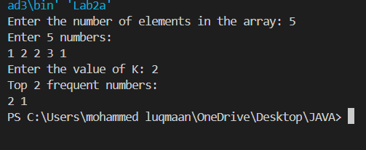

1. **Description:**

This program, named Lab2b, is designed to calculate the maximum profit a stock trader can make with at most two transactions (a buy and a sell). The objective is to find the optimal points in the stock price array where two non-overlapping transactions (one buy-sell followed by another buy-sell) will yield the highest possible profit.

The program uses an efficient approach with a time complexity of **O(n)**, making it suitable for large datasets while ensuring optimal profit calculation for two transactions.

**Output:**



